1. Method: Linear regression

ｈ（ｘ）＝ｔａｎｈ（ｘ）

訓練方面在-1到1之間採用200個數據

驗證方面在-1到1之間採用100個數據

Epoch為0到2000，每200計算一次training loss和 validation loss

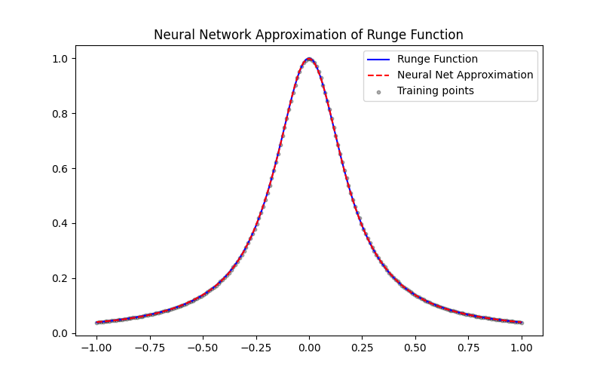

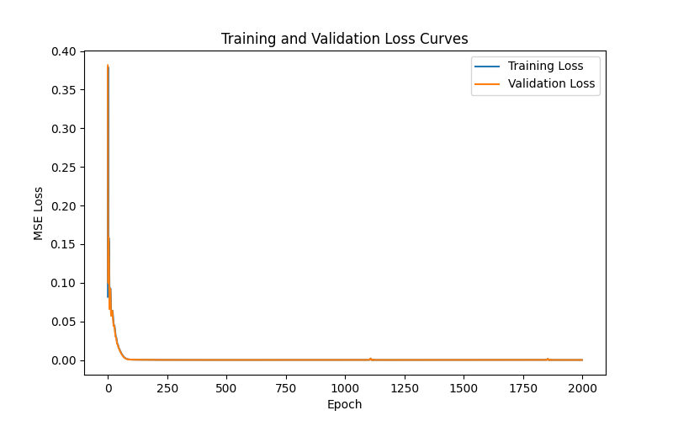

**Epoch 0, Train Loss: 0.081688, Val Loss: 0.381565**

**Epoch 200, Train Loss: 0.000130, Val Loss: 0.000129**

**Epoch 400, Train Loss: 0.000012, Val Loss: 0.000012**

**Epoch 600, Train Loss: 0.000003, Val Loss: 0.000003**

**Epoch 800, Train Loss: 0.000002, Val Loss: 0.000002**

**Epoch 1000, Train Loss: 0.000001, Val Loss: 0.000001**

**Epoch 1200, Train Loss: 0.000001, Val Loss: 0.000001**

**Epoch 1400, Train Loss: 0.000001, Val Loss: 0.000001**

**Epoch 1600, Train Loss: 0.000001, Val Loss: 0.000001**

**Epoch 1800, Train Loss: 0.000000, Val Loss: 0.000000**

**Final Test MSE: 5.423533e-07**

**Final Test Max Error: 1.928858e-03**

**（二）**Result:

隨著epoch的提高，training loss和 validation loss也隨之下降，圖形逐漸逼近 $ｆ（ｘ）＝\frac{１}{１＋{２５}^{ｘ}}，ｘ∈［－１，１］$

**Final Test MSE: 5.423533e-07**

**Final Test Max Error: 1.928858e-03**